Project Design Phase-II
Data Flow Diagram & User Stories
Date | 8 September 2026
Team ID | SWUID2026190365
Project Name | ServiceNow-Based Employee Laptop Request Application
Maximum Marks | 4 Marks
Data Flow Diagrams:
A Data Flow Diagram (DFD) represents how information enters, moves through, is processed, and is stored in the system. For this project, the DFD shows an employee submitting a laptop request through ServiceNow, the request being stored, the manager approval workflow being triggered, and the requester receiving the final status notification.
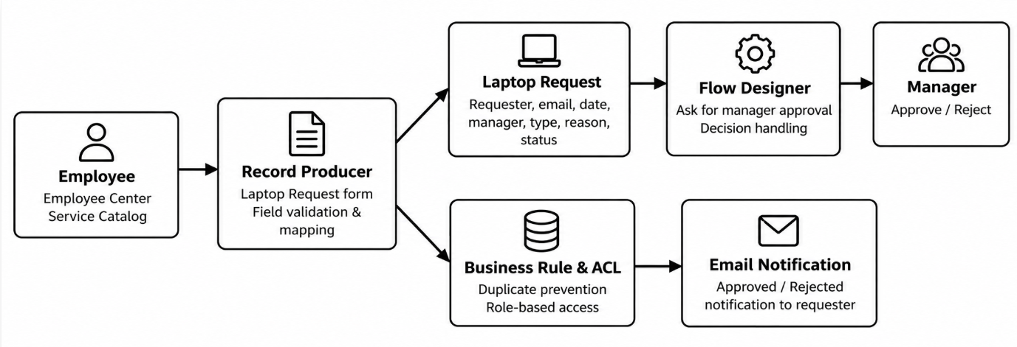
Project DFD: Employee → ServiceNow Request → Laptop Request Table → Manager Approval → Status & Email.
User Stories
The following user stories describe the main functions of the ServiceNow-based laptop request application.
User Type | Functional Requirement (Epic) | User Story Number | User Story / Task | Acceptance criteria | Priority | Release
Employee | Laptop Request | USN-1 | As an employee, I can submit a laptop request through the ServiceNow Employee Center. | A laptop request record is created with the required request details. | High | Sprint-1
Employee | Laptop Request | USN-2 | As an employee, I can select the type of laptop required (Basic or Advance). | The selected laptop type is stored with the request. | High | Sprint-1
Employee | Request Tracking | USN-3 | As an employee, I can view the status of my laptop request. | The request status shows Pending, Approval, Approved, or Rejected. | High | Sprint-1
Manager | Approval | USN-4 | As a manager, I can review and approve or reject an employee laptop request. | The approval record is assigned to the manager and the decision is recorded. | High | Sprint-1
System | Duplicate Prevention | USN-5 | As the system, I prevent the same employee from submitting more than one laptop request in a year. | A duplicate request is blocked with an appropriate message. | High | Sprint-1
Employee | Notification | USN-6 | As an employee, I receive an email when my laptop request is approved or rejected. | The requester receives the decision notification by email. | Medium | Sprint-2
IT Manager | Monitoring | USN-7 | As an IT manager, I can view laptop requests for tracking and accountability. | Authorized managers can read the laptop request records. | Medium | Sprint-2
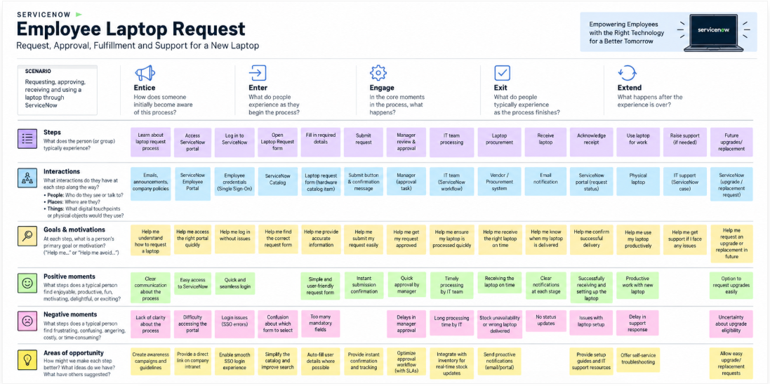

Solution Requirements (Functional & Non-functional)
Date | 8 September 2026
Team ID | SWUID2026190365
Project Name | ServiceNow-Based Employee Laptop Request Application
Maximum Marks | 4 Marks
Functional Requirements:
Following are the functional requirements of the proposed ServiceNow laptop request solution.
FR No. | Functional Requirement (Epic) | Sub Requirement (Story / Sub-Task)
FR-1 | Laptop Request Submission | Employee submits a laptop request using the ServiceNow Employee Center / Service Catalog Record Producer.
FR-2 | Request Details | Capture requester, employee email, request date, short description, manager, laptop type, reason and status.
FR-3 | Duplicate Prevention | Allow only one laptop request per employee per calendar year.
FR-4 | Manager Approval | Automatically send the request to the selected manager through Flow Designer for approval or rejection.
FR-5 | Status Management | Update the request status to Pending, Approved or Rejected according to the workflow outcome.
FR-6 | Notifications | Send an email notification to the requester after approval or rejection.
FR-7 | Access Control | Allow employees to create/read/write requests and managers to view requests according to assigned roles and ACLs.
Non-functional Requirements:
Following are the non-functional requirements of the proposed solution.
NFR No. | Non-Functional Requirement | Description
NFR-1 | Usability | The request form should be simple, clear and easy for employees to complete.
NFR-2 | Security | Role-based access and ACLs restrict who can create, read and modify laptop request records.
NFR-3 | Reliability | The approval flow and status updates should execute consistently without manual intervention.
NFR-4 | Performance | The form, request lookup and approval workflow should respond within normal ServiceNow application performance expectations.
NFR-5 | Availability | The application should be available through the organization's ServiceNow instance during supported service hours.
NFR-6 | Scalability | The centralized table and Flow Designer workflow should support increasing numbers of employees and requests.

Technology Stack (Architecture & Stack)
Date | 8 September 2026
Team ID | SWUID2026190365
Project Name | ServiceNow-Based Employee Laptop Request Application
Maximum Marks | 4 Marks
Technical Architecture:
The architecture uses ServiceNow as the centralized platform for employee laptop requests. Employees submit requests through the Employee Center/Service Catalog. The Record Producer creates a record in the custom Laptop Request Form table. Flow Designer sends the request to the manager, waits for approval or rejection, updates the status, and sends an email notification.
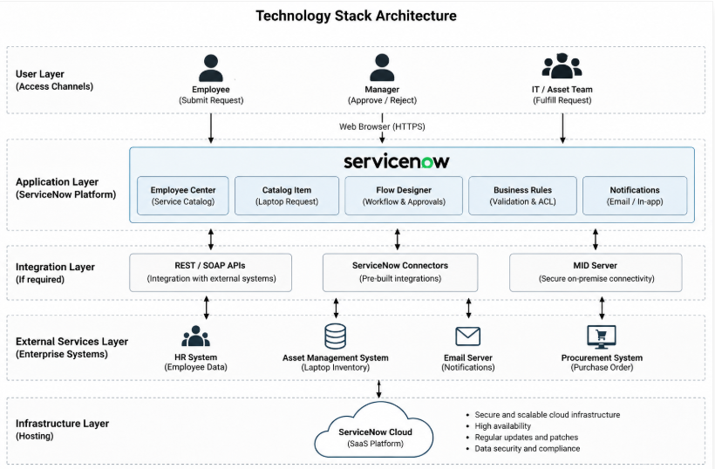
Project Technical Architecture
Table-1 : Components & Technologies
S.No | Component | Description | Technology
1 | User Interface | Employee and manager interaction with the application. | ServiceNow Employee Center / Service Catalog
2 | Application Logic-1 | Creates and manages laptop request records. | ServiceNow Custom Table & Record Producer
3 | Application Logic-2 | Automates manager approval and decision handling. | ServiceNow Flow Designer
4 | Application Logic-3 | Prevents duplicate yearly requests. | ServiceNow Business Rule
5 | Database | Stores laptop request and related application data. | ServiceNow platform database / custom table
6 | Cloud Database | Not separately required; data is maintained in the ServiceNow platform. | ServiceNow data platform
7 | File Storage | No separate file-storage component is required for the core application. | ServiceNow platform
8 | External API-1 | Not required for the core laptop request workflow. | Not applicable
9 | External API-2 | Not required for the core laptop request workflow. | Not applicable
10 | Machine Learning Model | No machine-learning model is required. | Not applicable
11 | Infrastructure (Server / Cloud) | Application is hosted and executed in the organization's ServiceNow instance. | ServiceNow cloud platform
Table-2: Application Characteristics
S.No | Characteristics | Description | Technology
1 | Open-Source Frameworks | No external open-source application framework is required for the core ServiceNow configuration. | ServiceNow platform configuration
2 | Security Implementations | Role-based access is implemented using it_manager and it_employee roles, groups and ACLs. | ServiceNow Roles, Groups and ACLs
3 | Scalable Architecture | Centralized table and workflow-based architecture can support additional employees and requests. | ServiceNow platform & Flow Designer
4 | Availability | The application is delivered through the organization's ServiceNow instance. | ServiceNow cloud platform
5 | Performance | Use simple forms, indexed platform fields and automated Flow Designer processing; avoid unnecessary manual steps. | ServiceNow platform
References
https://c4model.com/
https://developer.ibm.com/patterns/online-order-processing-system-during-pandemic/
https://www.ibm.com/cloud/architecture
https://aws.amazon.com/architecture/
https://medium.com/the-internal-startup/how-to-draw-useful-technical-architecture-diagrams-2d20c9fda90d

